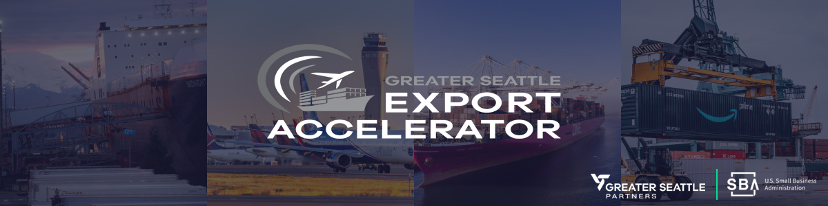**Important Dates**

* **Cohort #4: Interested Export Businesses Submit Online GSEA Application by: August 25, 2025**
* **GSEA Steering Committee Application Review & Notification Period: August 26 - September 6, 2025**

**GSEA MEETINGS SCHEDULE:**

**DATES**              **VENUE** (In-person & Online Meetings)         **PURPOSE** (Evaluate Export Readiness)

|  |  |  |
| --- | --- | --- |
| **September 8-12, 2025**  Online meetings to be scheduled | **Online Virtual meetings with GSEA Program Adviser- Vern Jenkins (45 - 60 minutes)** | To gain an understanding of your company’s products/services and current export goals. |
| **September 15-19, 2025**  1-hour meetings to be scheduled | **In-person visits - onsite at participating Export Business Location with GSEA Adviser: 45 - 60 minutes** | To gain an understanding of your company’s products/services and current export goals |
| **September 22, 2025**  4:00-6:00PM | **In-person GSEA launch Meeting and group orientation** for all Cohort (3) Business participating in the GSEA program. Held at the Washington Athletic Club (WAC) | **Introduction of GSEA Program** and Program Launch with Cohort FOUR Businesses and Seattle Area Partners |

|  |  |  |
| --- | --- | --- |
|  | **GSEA Participants Attend ONLINE Export Module (1) of (6)** |  |
|  | **Tuesday, September 30th –**  **Thursday, October 2nd**  **3:00- 4:30 PM** |  |
|  | **Online MS TEAMS Session (60-90 mins each)** Instruction by Vern Jenkins and invited experts |  |
| **Review Your Export Market Readiness** **and Business Plan Elements** | * Review company’s Export Readiness Initiatives * Evaluate your company’s operational & financial capabilities * Define your company’s desired export outcomes as related to business plan * Review selected products, production & shipping capabilities | Cohort (4) Businesses to complete GSEA Webinar Module ONE Online. |

|  |  |  |
| --- | --- | --- |
|  | **ONLINE Export Module (2) of (6)** |  |
|  | **Tuesday, October 7th –**  **Thursday, October 9th**  **3:00- 4:30 PM** |  |
|  | **Online MS TEAMS Session (60-90 mins each)** Instruction by Vern Jenkins and invited experts |  |
| **Review Your Export Business Plan and Market Entry Strategies** | * Review your export management team * Identify and select helpful export assistance programs * Discuss export market entry strategies and related export business plans * Review SWOT homework assignment | Cohort (4) Businesses to complete GSEA Webinar Module TWO Online. |

|  |  |  |
| --- | --- | --- |
|  | **ONLINE Export Module (3) of (6)** |  |
|  | **Tuesday, October 14th –**  **Thursday, October 16th**  **3:00- 4:30 PM** |  |
|  | **Online MS TEAMS Session (60-90 mins each)** Instruction by Vern Jenkins and invited experts |  |
| **Review Foreign Market Opportunities, Risks and Barriers** | * Research your product demand in targeted foreign markets * How to evaluate foreign market sales and distribution channels * Evaluate risks and barriers for selected market(s) (SWOT) * Review Landed Costs Formula | Cohort (4) Businesses to complete GSEA Webinar Module THREE Online. |

|  |  |  |
| --- | --- | --- |
|  | **ONLINE Export Module (4) of (6)** |  |
|  | **Tuesday, October 21st –**  **Thursday, October 23rd**  **3:00- 4:30 PM** |  |
|  | **Online MS TEAMS Session (60-90 mins each)** Instruction by Vern Jenkins and invited experts |  |
| **Review Shipping Terms and Calculating Landed Costs for target Export Products** | * Calculate your product(s) landed costs for selected markets * Best practices for qualifying your potential foreign buyers * Guidelines for shipping products overseas (Incoterms) | Cohort (4) Businesses to complete GSEA Webinar Module FOUR Online. |

|  |  |  |
| --- | --- | --- |
|  | **ONLINE Export Module (5) of (6)** |  |
|  | **Tuesday, October 28th –**  **Thursday, October 30th**  **3:00- 4:30 PM** |  |
|  | **Online MS TEAMS Session (60-90 mins each)** Instruction by Vern Jenkins and invited experts |  |
| **Export Business Plan and Financing with EXIM and/or SBA International Trade Programs** | * Review credit policies and foreign buyer payment terms * Estimate timelines and cost for increased production capacity * Evaluate Exim Bank and SBA Financing options for Exporters * Review current business Module | Cohort (4) Businesses to complete GSEA Webinar Module FIVE Online. |

|  |  |  |  |
| --- | --- | --- | --- |
|  | **ONLINE Export Module (6)** |  | |
|  | **Tuesday, November 4th –**  **Thursday, November 6th**  **3:00- 4:30 PM** |  | |
|  | **Online MS TEAMS Session (60-90 mins each)** Instruction by Vern Jenkins and invited experts | |  |
| **Export Business Model Review and Export Compliance with Int’l Attorney** | * Summarize current business model for exporting to foreign markets * Review trademark and IP issues and other export compliance regulations * Review key elements for export business plan presentation | Cohort (4) Businesses to complete GSEA Webinar Module SIX Online. | |

|  |
| --- |
| **Note: Participating Cohort Businesses will have Homework Assignments related to Each Online Module** |

|  |  |  |
| --- | --- | --- |
| **Week of November 10 – 14, 2025**  Vern Jenkins conduct Onsite Visits | Vern Jenkins conduct **One-on-One Trade Advising Meetings with each Cohort Business** to review their Export Business Plans and Market Entry Readiness | **Prepare Cohort Business for presenting their Export Business Plan** based on selected product & target foreign markets |

|  |  |  |
| --- | --- | --- |
| **November 17th 2025, Presentation & Celebration Lunch** 10:00 AM – 1:00 PM (Location TBD) | **Export Business Plan Presentation by Each Cohort Business:** In-person meeting to share Export Business Plan and key strategies for entering selected foreign markets. | **Have Cohort Businesses Present their Export Business plans** based on selected product(s) and target foreign markets |